Orphaned Tokens Removal

An orphaned token is a pointer that is associated with an activity that was removed from a business process definition (BPD).

You can use any of methods to manage orphaned tokens.
1.a Policy file
2.a REST API
3. Process Inspector

A token becomes orphaned if its associated activity is removed from a BPD of a migrated snapshot.

Steps for removing orphan Tokens Using Policy File

Step-1:-
To implement this process we need to create a BPD which is having three Activites let us say A,B and C.

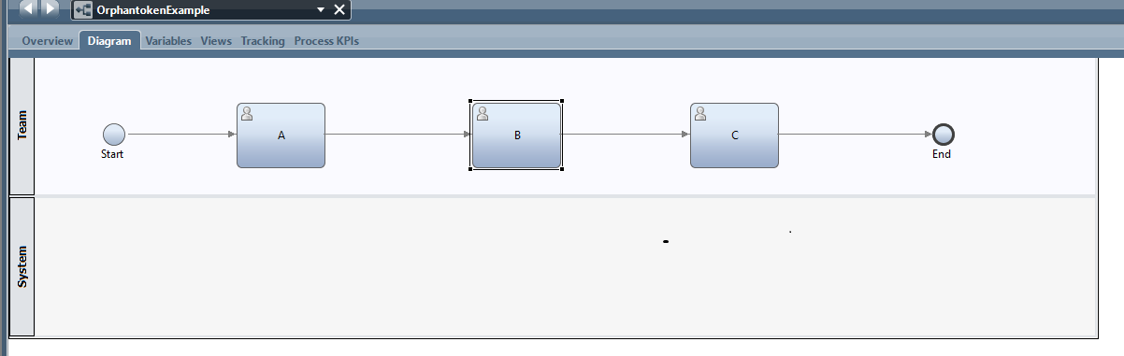
Then start the instance and the token will be at Activity “A”

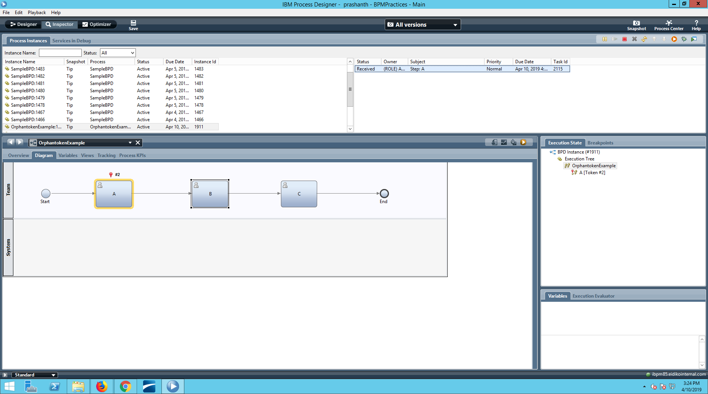
then finish the task and refresh ,the token will moved to Activity “B”

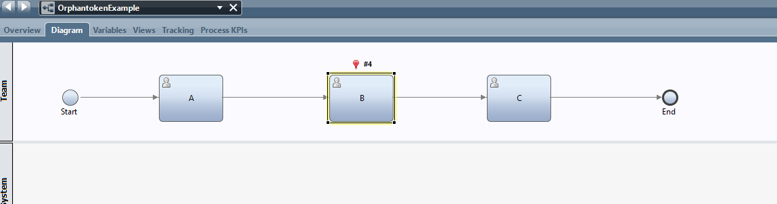
Now , Take a SnapShot for this version and Name it as version_1.

Step-2:-
For some business requirements ,let the activity B has been removed from the BPD.But,the token is still waiting at the Activity B.These are called Orphan Tokens.

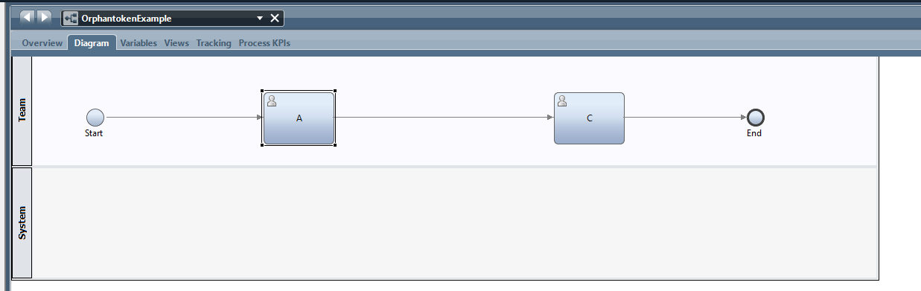
After the removal of Activity “B”

When you are installing a new version of a process application. A number of explicit exception events have been removed from some of the nested processes. This removal could potentially lead to orphaned tokens when instances are migrated to the new version. It should be possible to delete (that is, to ignore) these tokens when instances are migrated from the old to the new version of the process without causing instances to hang.

* When a process instance is live, it is based upon a snapshot definition of a process application. If we deploy a new snapshot definition of the same process, this is where migration can take effect. Due to this we need to migrate instances from one snap shot to another .

Step-3:
Now ,goto Process Center console using this URL
http://ibpm85:9081/ProcessCenter
Open the process application and you can see the snapshots that you have taken in your BPD.
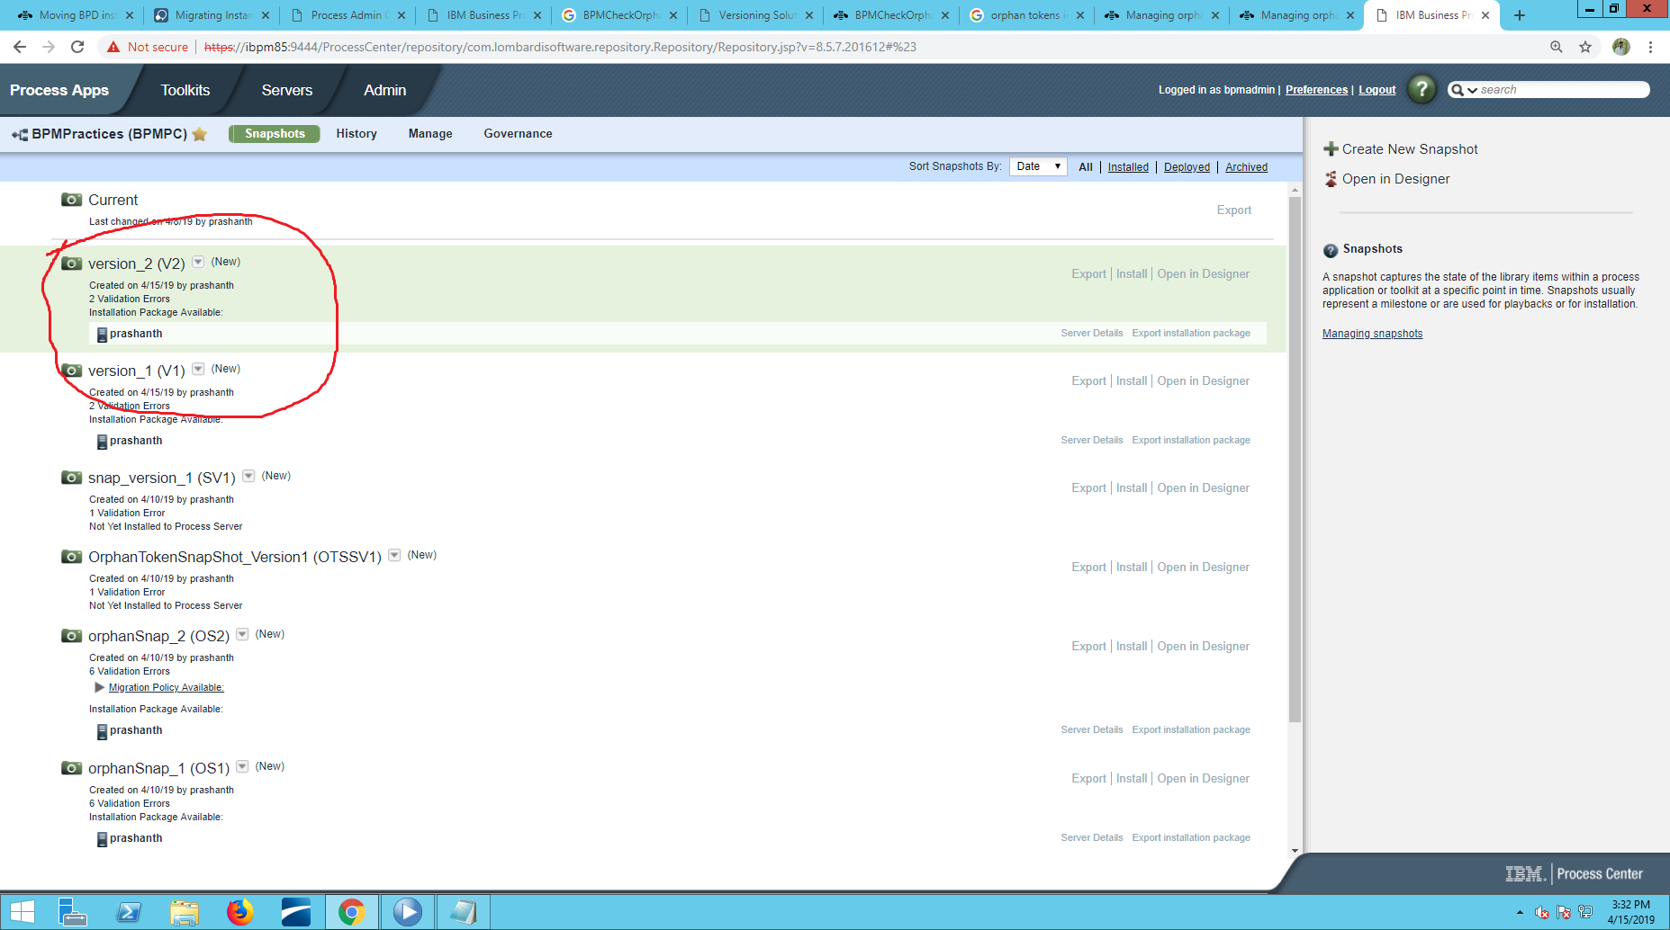

Here,Firstly activate your snapshots by clicing the drop down .
Step-4:
Create a offline server in the process center and deploy the snapshots onto the offline server
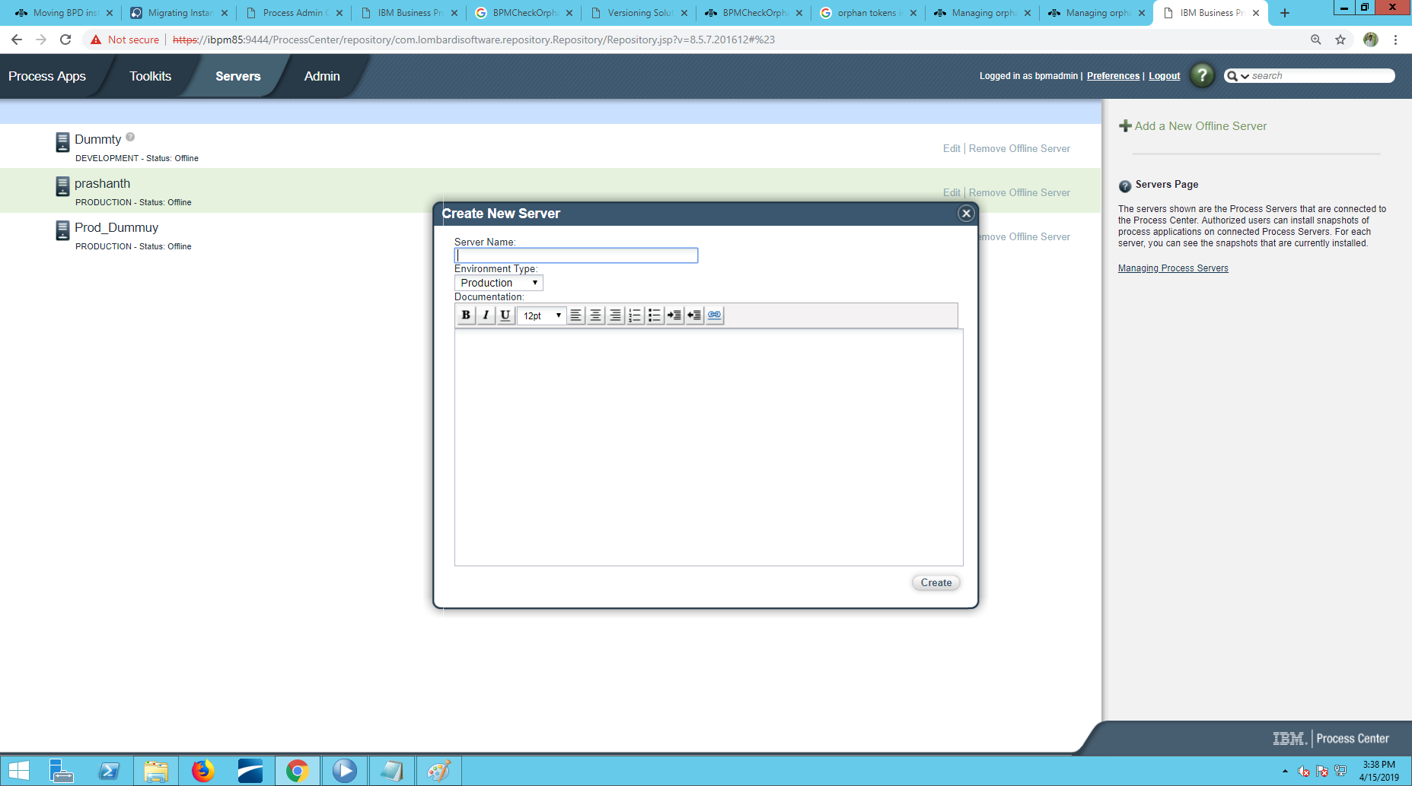

Step-5:
Open the ProcessAdmin console using URL and open InstalledApps
http://ibpm85:9081/ProcessAdmin

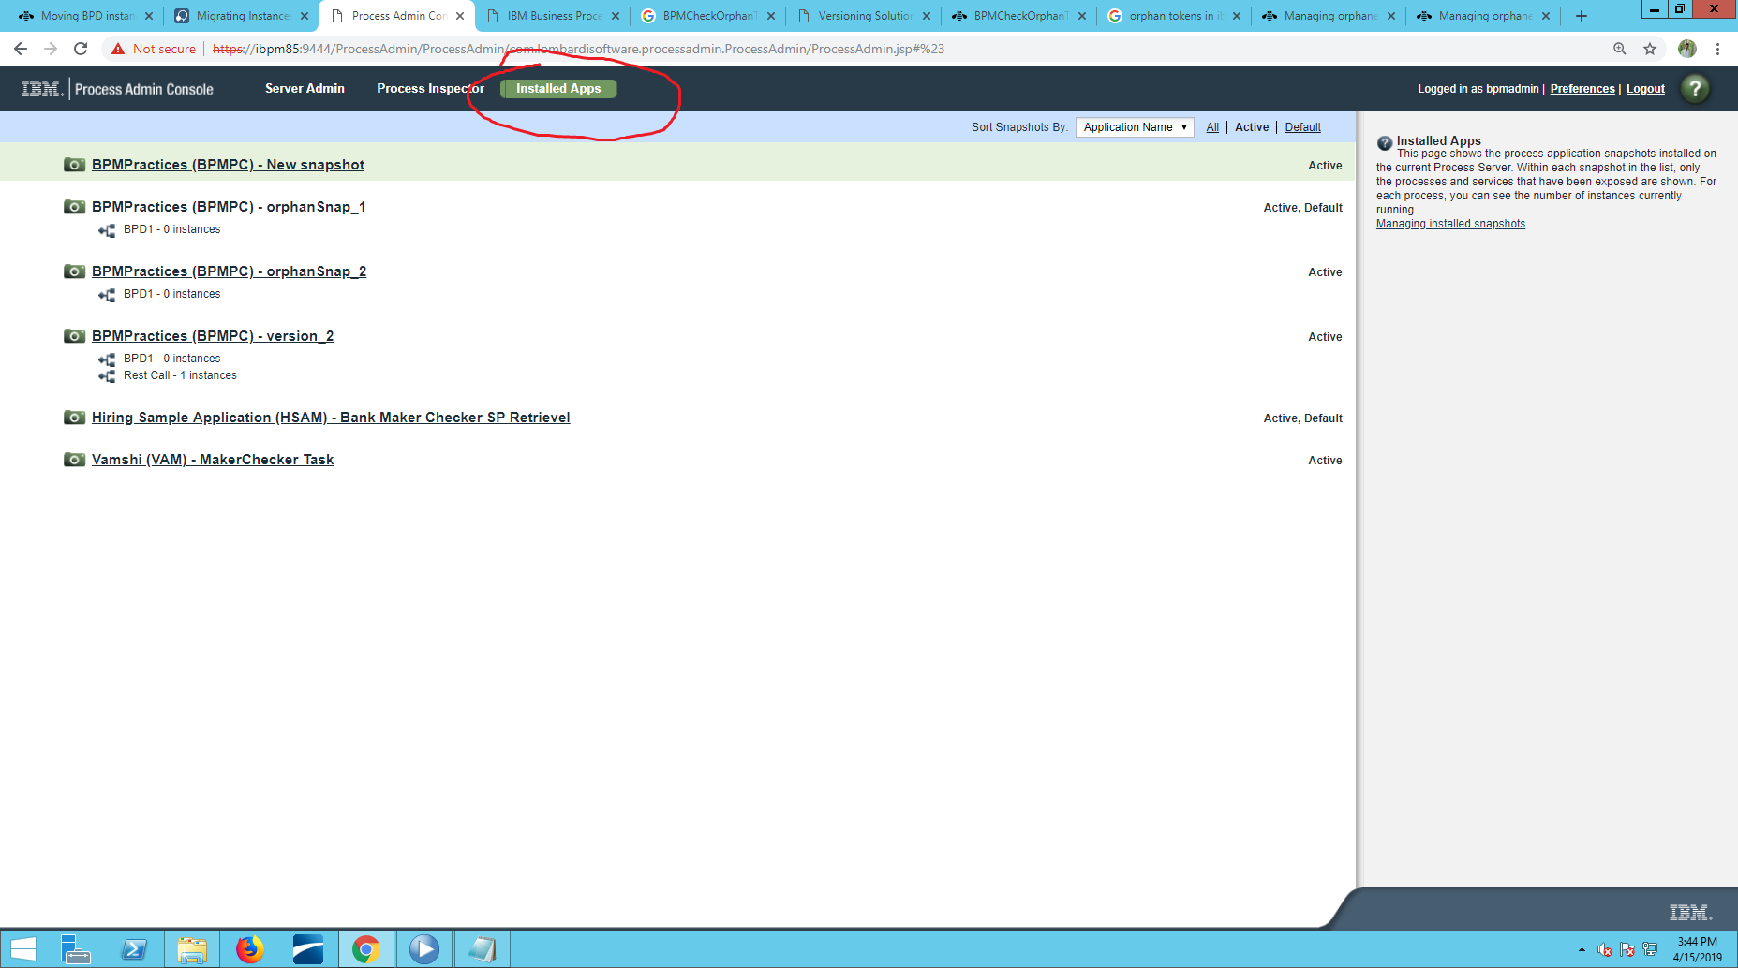

open the Second snapshot as first snapshot(version_1) has an instance of the process called BPD1 still running .

Step-6:
Select the Migrate Inflight data option

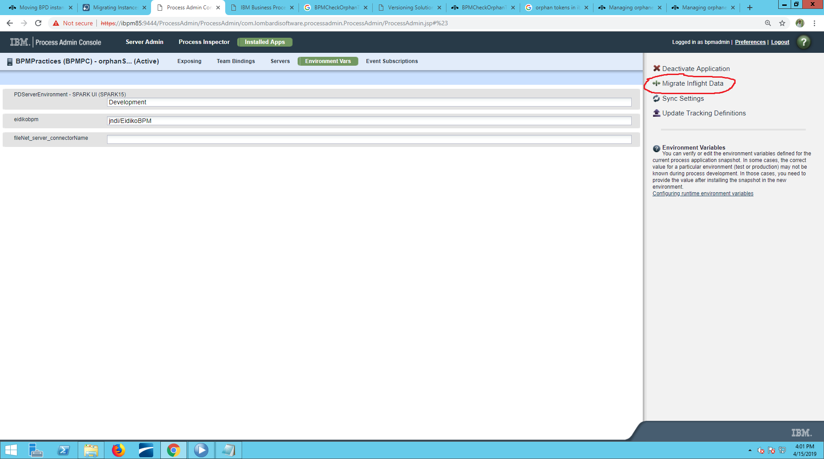
Now,you can see the first snapshot name displayed on the screen,select the snapshot
and click
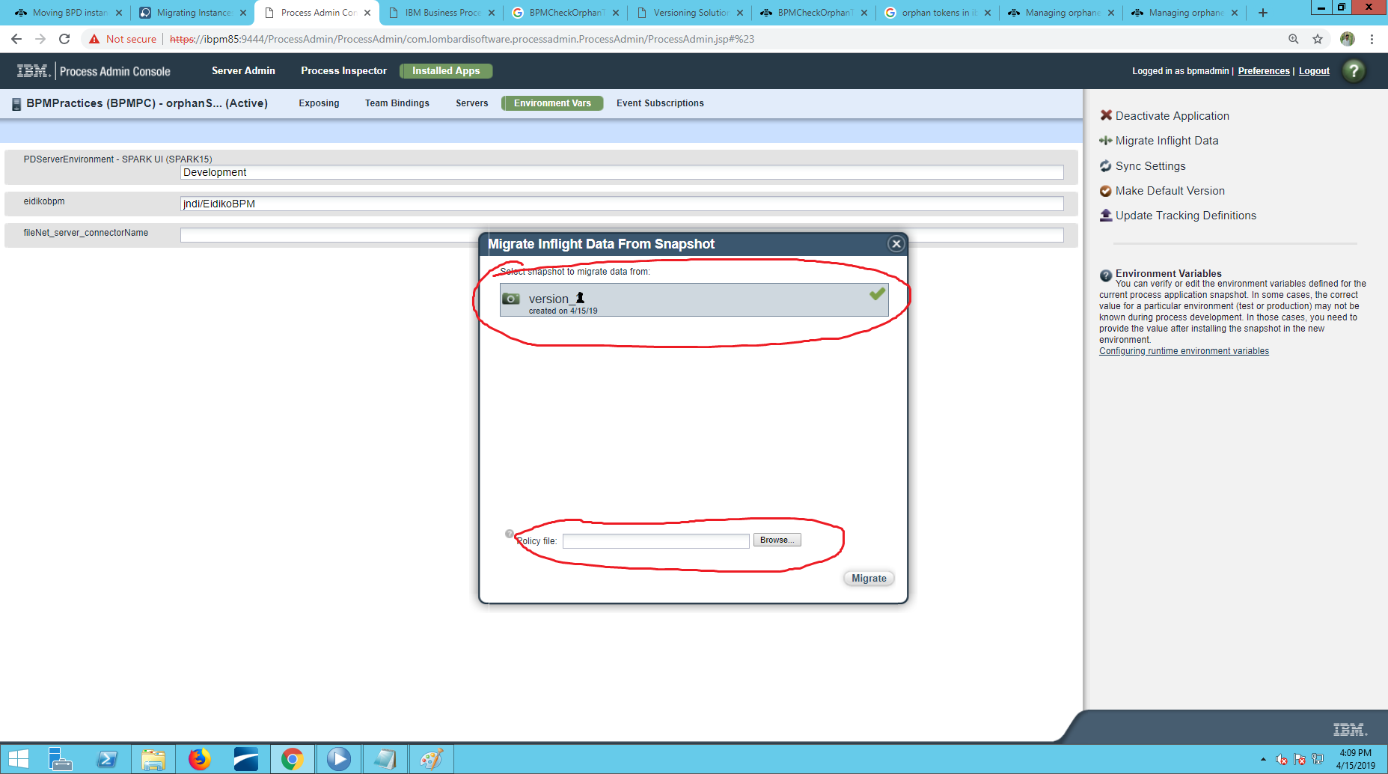

Step-7:
create a Policy file using the wsadmin scripting commands

firstly, on Process Center System
Goto to path /opt/IBM/WebSphere/AppServer/profiles/Node1Profile/bin/

next, type command
cmd:-./wsadmin.sh -host ibpm85 -port 8881 -lang jython
next appears as to enter user name and password ,type it
Realm/Cell Name: <default>
Username: bpmadmin
Password:

here,
host :- hostname of the Process Center
Port :- the port number of AppCluster server whisch you can get in WAS console
Servers->All Server-> AppClusterMember1 ->Ports->SOAP_CONNECTOR_ADDRESS
lang :- wsadmin Scripting language used.By default, jacl is held. We used jython

wsadmin commd will be BPMCheckOrphanTokens with parameters
processAppAcronym – accronym of Process app
sorceSnashotName – first snapshot name
targetSnapshotName – second snapshot where migration is to be held
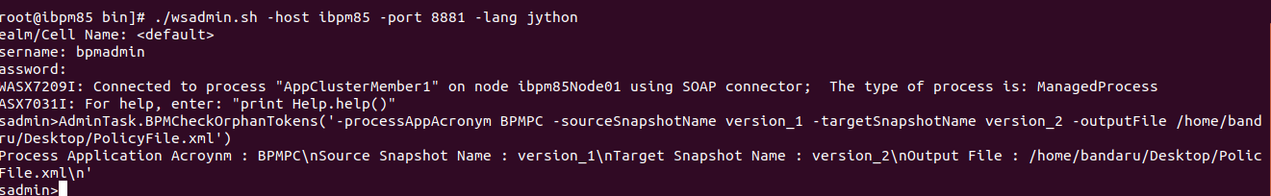
outputFile – file to store the policy file data

Copy the Policy file to your system,the xml file looks as follows
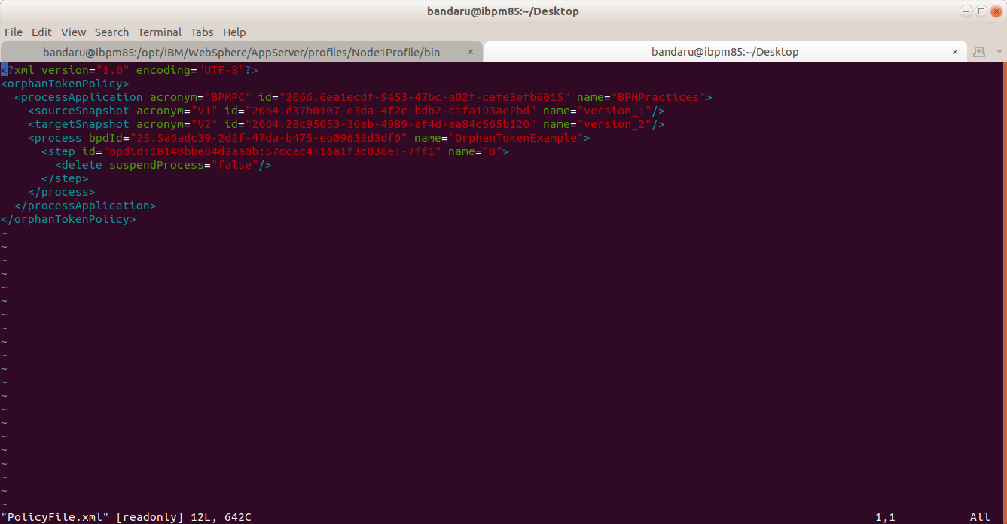
note: the policy file will bein xml format

Step-8:-
now browse the xml file path in the location and click on migrate.

Then you will able to see like this
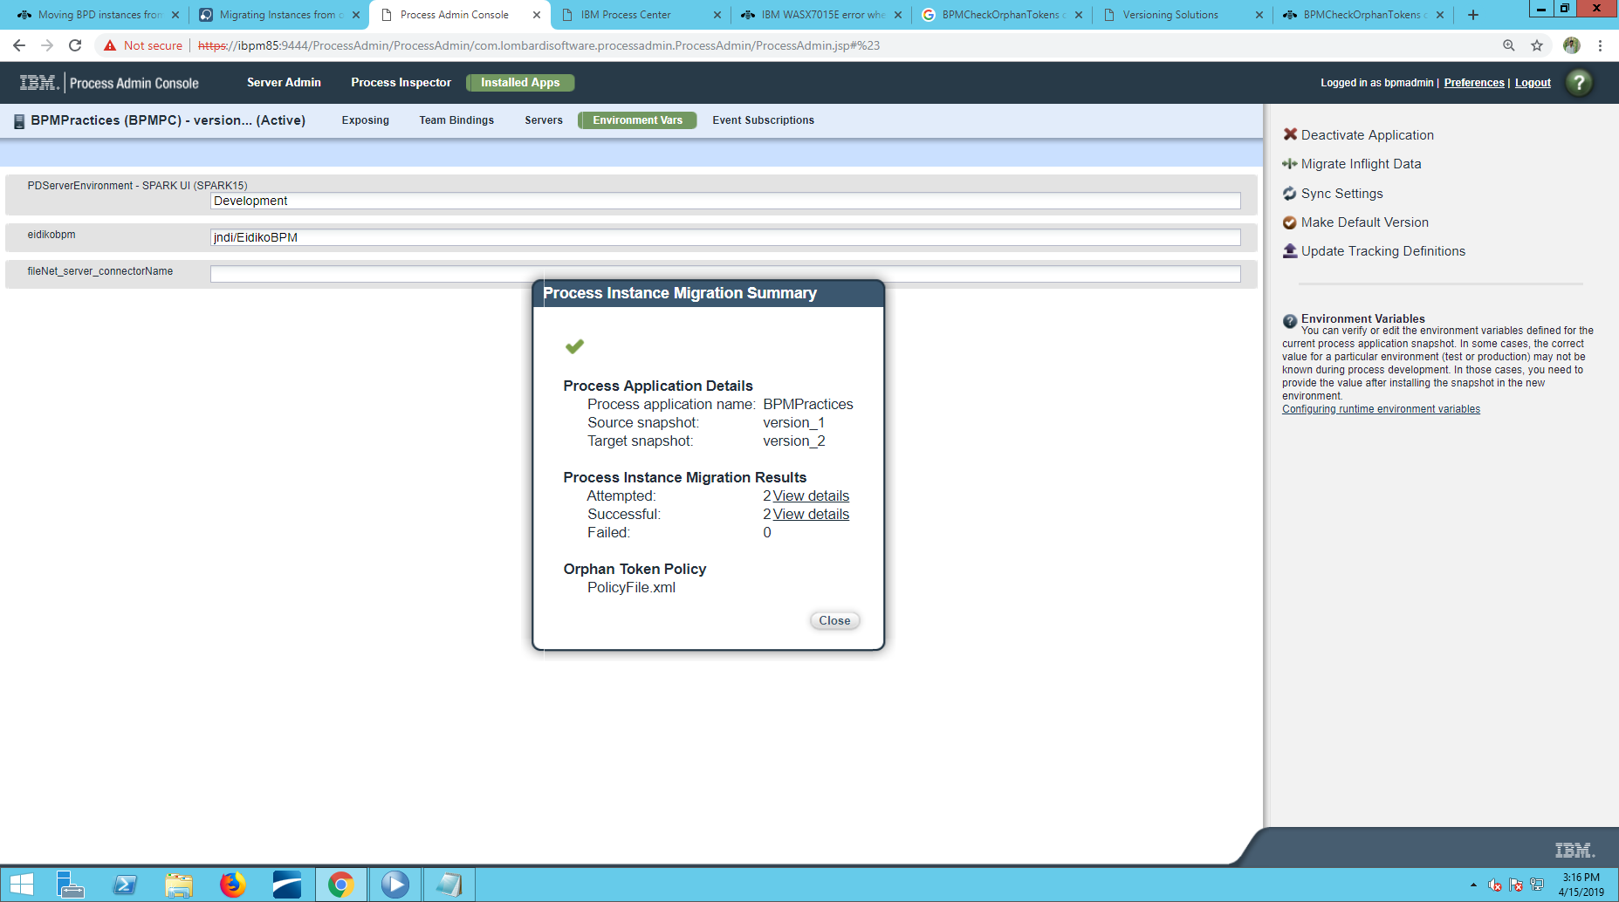

Steps for removing orphan Tokens Using REST API Tester
The REST API Tester is a stand-alone web application that you can use to test BPM-related REST resources. These APIs can also be called directly from a web browser by passing the correct parameters and following the syntax for the API.

we will use the IBM provided REST API Tester to manage our orphan tokens.

Step-1:
Navigate to the REST API Tester using the following URL
http://ibpm85:9081/bpmrest-ui/BPMRestAPITester/index.jsp

Step-2:
Select "Business Process Manager REST APIs",then select "Process API", then select "Current State".

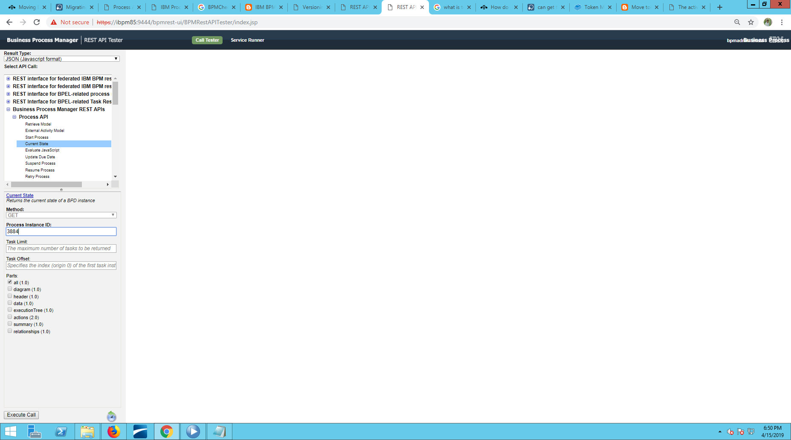

Step-3:
Enter Process Instance Id(In this case-3884) & then Click on Execute Call.
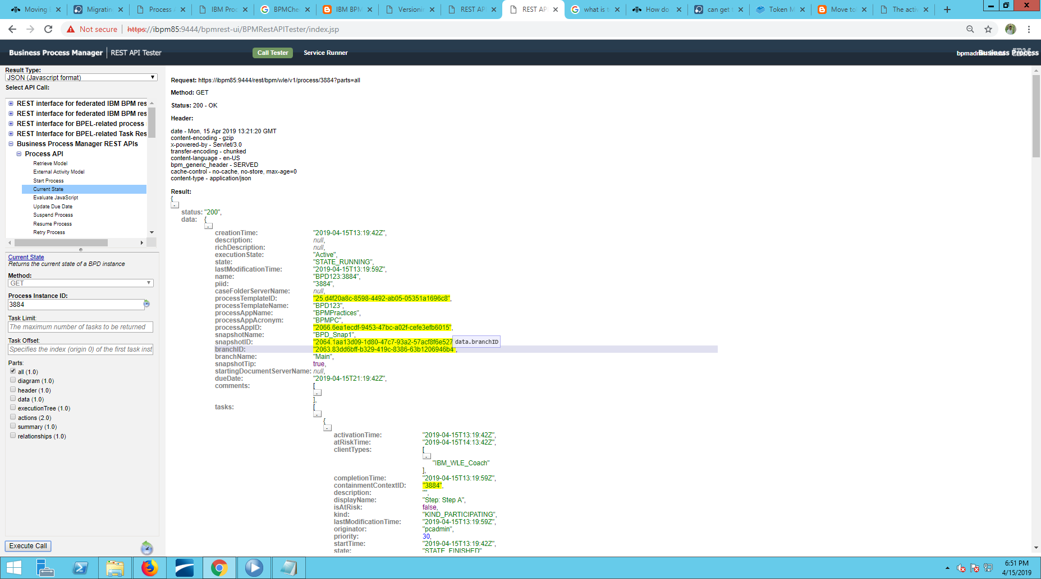

Step 4:
Look for Token Id (In this case Token Id-4)

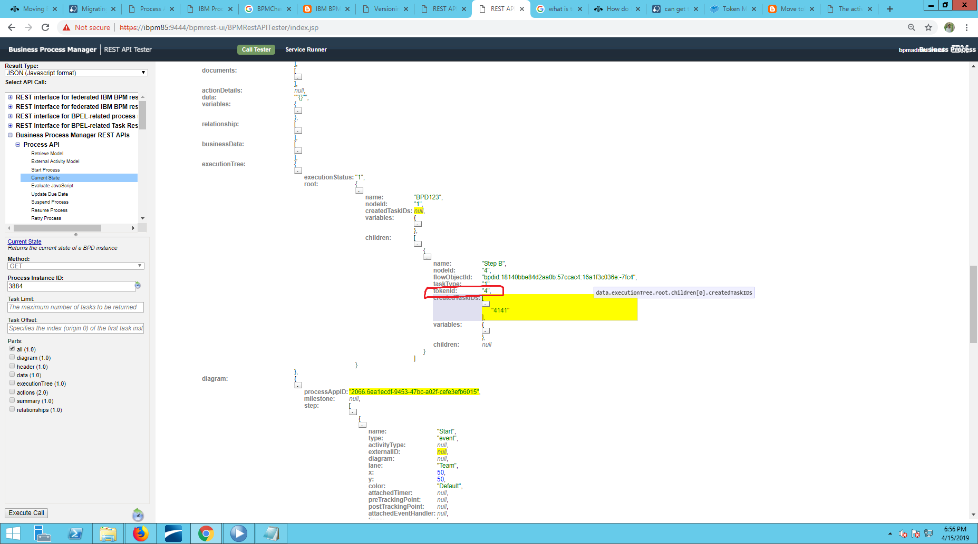

Step 5: Look for Source Step Id(In this case -bpdid:18140bbe84d2aa0b:57ccac4:16a1f3c036e:-7fbe)
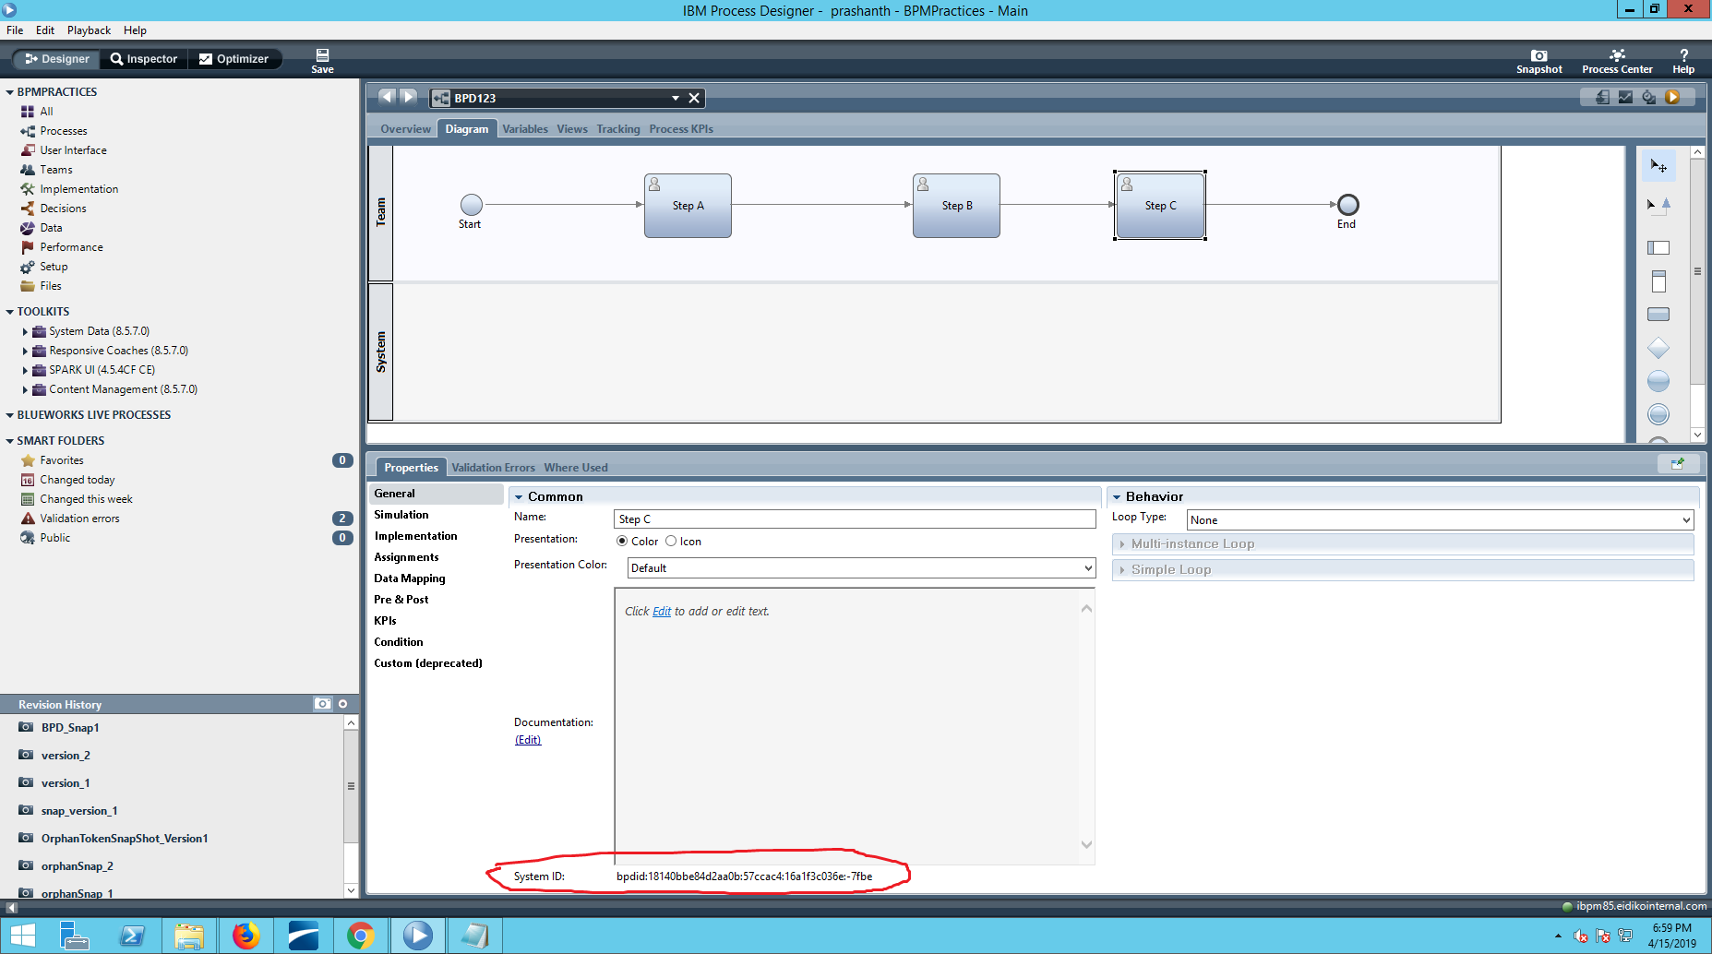

Step 6: In Process API list Click on "Move Token".

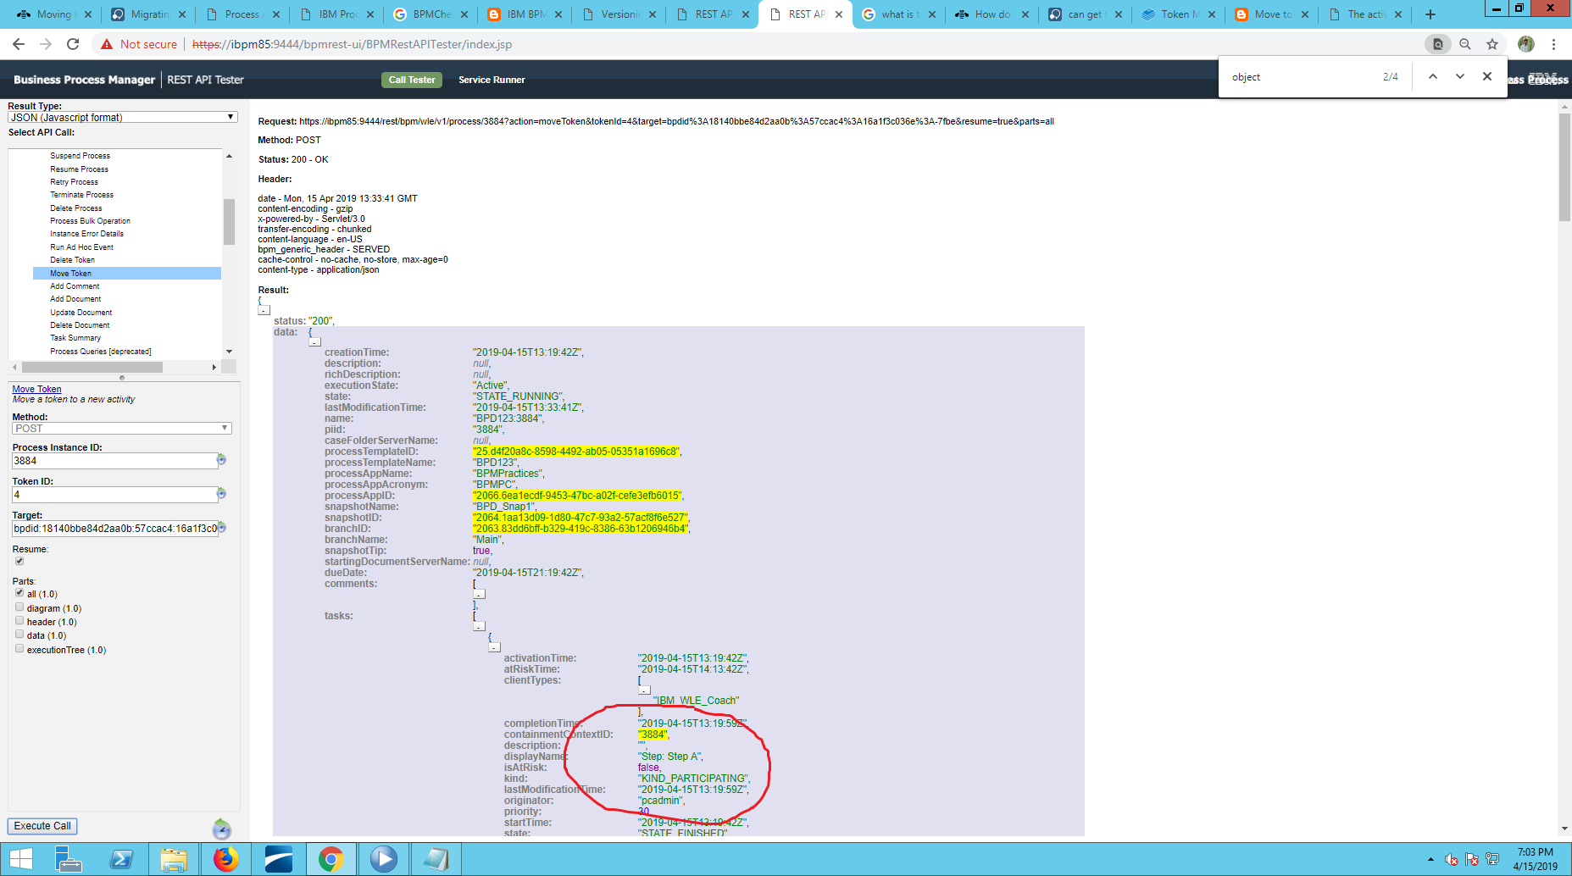
Instance ID,Token ID & Target Step Id, Then click onexecute call.

Step 7:Status 200shows that Token moved successfully.

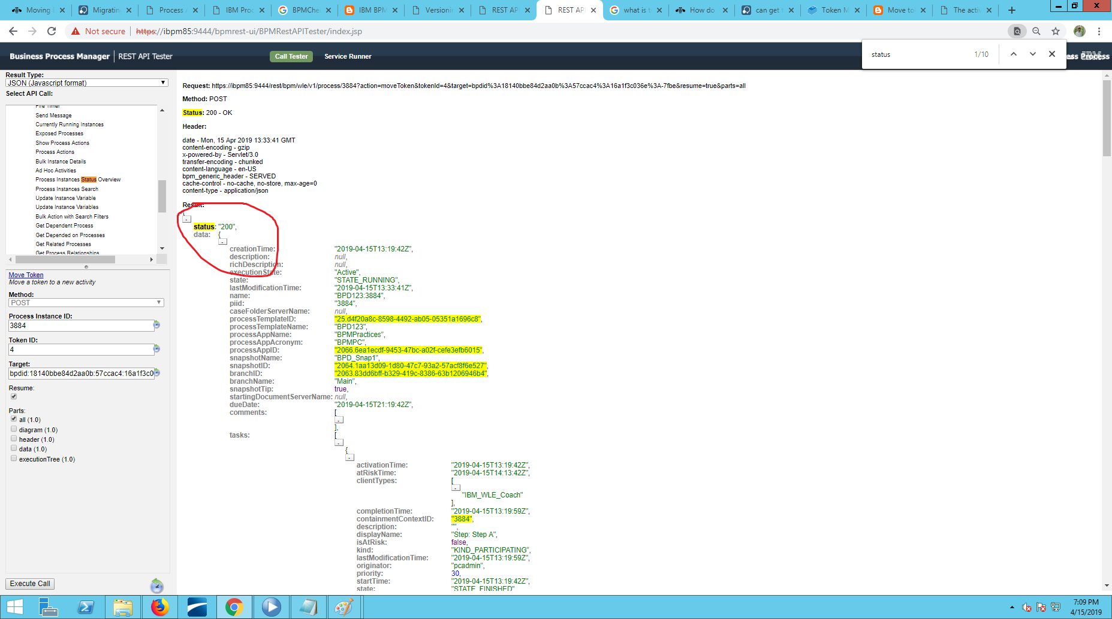

Step 8:- you can see the token moved to step C

